**cWofkg sfo{sf] lg/Gt/tf / ;qfGt k/LIff ;DjGwL ;"rgf**

**-ldltM @)&*⁄)@⁄!$_**

ljZjAofkL ?kdf km}lnPsf] sf]le8–!( sf] dxfdf/Ln] lzIff If]q klg k|efljt ePsf] tYo ;j{ljlwt g} 5 . t;y{, dWoklZrdf~rn ljZjljBfnon] ;Dk"0f{ txsf rfn' ;]d]:6/sf sIffx? cgnfOg dfWodaf6 ;+rfng ub{} cfO/x]sf] 5 . ;a} ;]d]:6/sf ;qfGt k/LIff ljBfyL{x?sf] ef}lts pkl:yltdf tf]lsPsf] k/LIff s]Gb|df g} x'g] ePsf]n] ;a} SofDk;x?nfO{ cgnfOg ljlwaf6} ljBfyL{x?sf] k7gkf7g, cfGtl/s d"NofÍgsf lqmofsnfkx?, / dWojlt{ k/LIff ;d]t ;+rfng ug{ / ;DjlGwt ;]d]:6/sf] k9fO{ / cfGtl/s d"NofÍgsf ;Dk"0f{ lqmofsnfkx? ;dfKt ePsf ljBfyL{x?nfO{ pKfNnf] ;]d]:6/df cku]|8 u/L lghx?sf] cWofkg sfo{ Pjd\ cfGtl/s d"NofÍgsf s[ofsnfkx? cgnfOg ljlwaf6} :f'rf? ug{ cg'/f]w 5 .

;qfGt k/LIff glbO{ pkNnf] ;]d]:6/df cku|]8 ul/Psf ljBfyL{x?sf] ;DjlGwt ;]d]:6/x?sf ;qfGt k/LIff sf]le8–!( sf cj:yf, o;sf] c;/ / g]kfn ;/sf/sf] lg0f{o cg';f/ pko'Qm ;dodf ljBfyL{x?nfO{ ;xh x'g]u/L ;+rfng ul/g] Aoxf]/f ;DjlGwt ;a}nfO{ o;} ;"rgf4f/f ;"lrt ul/G5 .

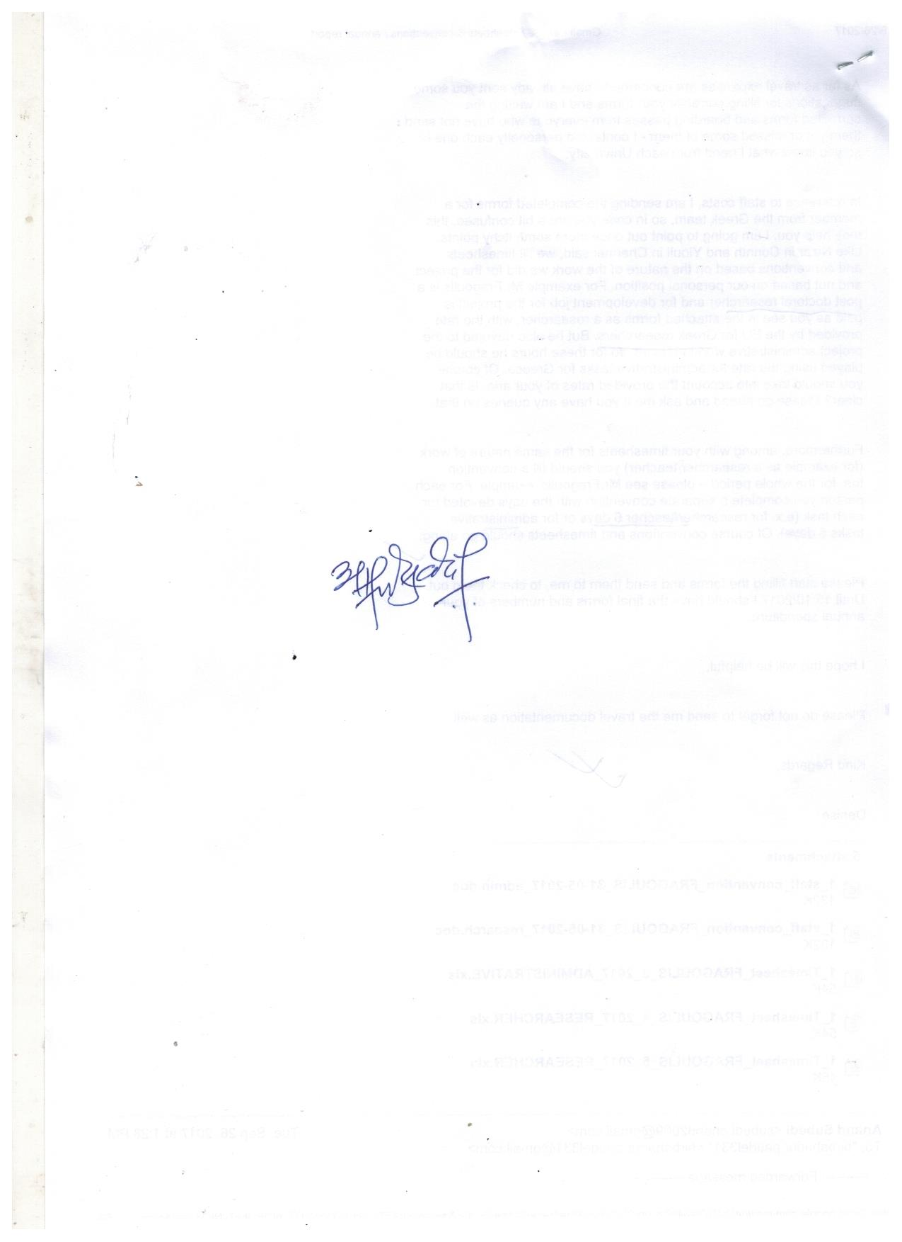

k/LIff Aoj:yfkg k|d'v