**6«fG;lqmK6÷k|f]lehgn ;l6{lkms]6÷dfOu|]zg ;l6{lkms]6dfq hf/L ug{] :f'rgf**

**ldlt M @)&*÷)@÷!&**

xfn ljZjAofkL?kdf km}ln/x]sf] sf]/f]gf efO/;sf] gof“ e]l/oG6af6 x'g;SGF] ;+qmd0fsf] hf]lvd lgoGq0f Pj+ /f]syfdsfnflu lhNnf sf]le8–!( ;+s6 Aoj:yfkg s]Gb| -DCCMC_ ;'v{]tsf] lg0f{o cg';f/ ldlt @)&* ;fn h]i7 @% ut];Dd lhNnf k|zf;g sfof{no, ;'v{]tn] lgif]wf1f hf/L u/]sf]n] pQm cjlwe/ o; sfof{no lgoldt ?kdf k"j{jt 9+un] ;+rfng gx'g] ePsf]n] o; ljZjljBfnoaf6 s'g}klg tx kf/ u/L 6«fG;lqmK6÷k|f]lehgn ;l6{lkms]6÷dfOu|]zg ;l6{lkms]6 lng'kg{] ljBfyL{x?sf] xsdf pQm ;l6{lkms]6x? hf/L ug{] ;]jfsf]nflu dfq k/LIff Aoj:yfkg sfof{no ldlt @)&* ;fn h]i7 !* ut] lbgsf] !!M)) ah] b]lv $M)) ah] ;Dd v'Nnf /xg]5 .

;DjlGwt ljBfyL{x?n] o;} ;'rgf;fy ;DnUg cfj]bg kmf/d e/L k/LIff Aoj:yfkg sfof{nosf] gfddf g]kfn a+unfb]z a}Í ;'v]{tdf /x]sf] vftf g+ )@*))$#!! **C** jf /fli6«o afl0fHo a}Í ;'v]{tdf /x]sf]] vftf g $)*)!))))(%&%))!+ df tf]lsPsf] b:t'/ lt/]sf] ;Ssn a}Í ef}r/ jf ljw'tLo dfWodsf] k|of]u u/L k/LIff Aoj:yfkg sfof{nosf] vftfdf z'Ns hDdf u/]sf] k|df0fsf] lk|G6k|lt / cfjZos sfuhftx? ;DnUg u/L cfj]bg kmf/d;+u} k]z ug'{xf]nf . z'Ns / cfjZos sfuhftx? ;DjGwL hfgsf/L http://www.muexam.edu.np/pages/details/citizen_charter af6 lng ;lsg]5 .

l:ylt ;fdfGo ePkl5 ;Dk"0f{ ;]jfx? k"j{jt 9+un] ;'rf? x'g]x'bf 6«fG;lqmK6÷k|f]lehgn ;l6{lkms]6÷dfOu|]zg ;l6{lkms]6 lng clt h?/L ePsf ljBfyL{x?n] dfq ;Dks{ ug'[{xf]nf .

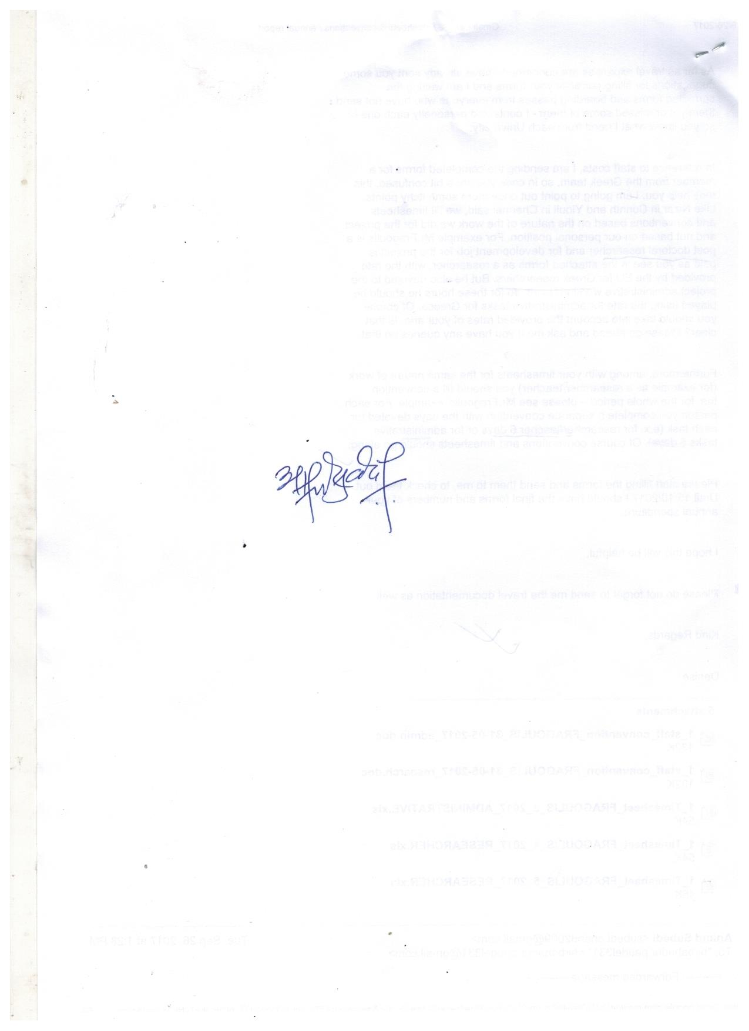

**k/LIff Aoj:yfkg k|d'v**